Our Joint Clinical Strategy for
Research, Development and Innovation

2022 - 2027

Contents

Foreword 3
Context 4
About the Trusts 4
Alignment of plans 4
National and regional context 5
Local context 6
Introduction 7
Developing our strategy 7
Our Journey 8
Our mission and vision 10
Our mission 10
Our vision 10
Our ambition 11
Ambition 1: Develop and deliver high quality research of direct patient benefit, tackling health and care inequalities 12
Ambition 2: Embed an inclusive research active culture in clinical service delivery, our community and across the Trusts 16
Ambition 3: Become a national leader in integrating RD&I strategically and operationally into developing clinical services 18
Ambition 4: Increase research funding and utilise to support strategic ambitions 19
Key indicators of success 20
Conclusion 22
Find out more 22
References 23

Foreword

The local, regional and global response to the COVID-19 pandemic has highlighted the critical importance of clinical research, increasing awareness and interest from our staff and patients alike.

It is well known that clinical research provides the evidence base to answer key questions that help us tackle health and care issues in our population. However, clinical research and its outcomes can also make a real difference to clinical care, patient experience, and organisational reputation, as well as staff satisfaction, development, recruitment and retention. Embedding and maintaining an active research ethos across Stockport NHS Foundation Trust and Tameside and Glossop Integrated Care NHS Foundation Trust is therefore vital to fostering a better future for our patients and staff.

That is why research, development and innovation are cited as key enabling themes of our Trust strategies. This Clinical Strategy for Research, Development and Innovation (RD&I) aligns closely to the ambitions of our Trusts and is key to enabling the delivery of both strategies. In developing a joint strategy, we aim to maximise the potential of this service across our two organisations.

Our strategy sets out how we will build on the existing research infrastructure and collaboration across the two Trusts, with scope to expand across the whole South East Sector of Greater Manchester. Our aspiration is to establish our reputations as organisations with regionally and nationally acclaimed research portfolios, delivering high quality research in collaboration with system partners and Integrated Care Systems to make a tangible difference to patient care.

This strategy isn’t just about those staff that currently deliver research within our Trusts. It looks to the wider workforce to consider their role in RD&I, from signposting patients to research opportunities for their conditions, sharing our research active ethos, updating clinical skills and practices in line with the latest research, to undertaking their own research activities. We want to develop a real culture of RD&I across our two Trusts, extending throughout the South East Sector, to improve the health, well-being and wealth of the populations we serve.

 |  |  | 
Andrew Loughney | Karen James OBE |  | Dilraj Sandher
Medical Director | Chief Executive Officer |  | Medical Director
 |  | 

Context

About the Trusts
Stockport NHS Foundation Trust (SFT) and Tameside and Glossop Integrated Care NHS Foundation Trust (TGIC) aim to be well-led organisations delivering safe, high quality care for local people.

Our Strategic Plans were developed in collaboration with our staff and patients, setting out clear visions for the future.

Our Trusts: |  | 
Our Mission: | Making a difference every day | Beyond Patient Care to Population Health
Our Values: | - We Care  - We Respect  - We Listen | - Safety  - Care  - Respect  - Communication  - Learning
Our Strategic Objectives: | - A great place to work  - Always learning, continually improving  - Helping people live their best lives  - Investing for the future by using our resources well  - Working with others for our patients and communities | - Support local people to remain well  - Provide high quality integrated services  - Develop and retain a workforce fit for the future  - Work with partners to innovate, transform and integrate care provision  - contribute to the delivery of financial sustainability

Alignment of plans

Our long-term Trust strategies are delivered through a range of medium-term business strategies, which set out the detail of how we will achieve our ambitions across our clinical divisions and enabling functions such as workforce, informatics, and estates.  Each year, the Trusts develop annual operational plans for in-year priorities, which align to national policy and delivery of our strategic objectives. This hierarchy of plans is set out in the figure to the right.  This document sits among our business strategies, detailing our medium-term plans to deliver the Trust’s vision. | 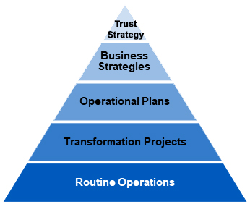

National and regional context

The National Institute for Health and Care Research (NIHR) was founded in 2006 with a clear mission to ‘improve the health and wealth of the nation through research’. The Care Quality Commission (CQC) has also incorporated research into its inspection framework through the ‘well-led’ domain, assessing the organisation-wide structure with a focus on the systems and processes for learning, continuous improvement and innovation.

The need for the NHS to work better with the commercial life sciences industry has been widely recognised by many funding bodies, with significant investment needed. The Government Industrial Life Sciences Sector Deal 2 publication sets out aims and objectives to ensure partnership working across sectors to advance the care we offer to our patients, whilst also driving RD&I to a level where the UK is recognised as a global leader. The UK government has confirmed its commitment to this by setting an ambition to triple investment into healthcare research to £900 million by 2027. Such expansion would bring further financial benefit to the NHS, allowing capacity building for Trusts to deliver more. The NIHR Clinical Research Network Impact and Value Assessment cites KPMG analysis of the benefits of participating in commercial drug studies, where NHS Trusts received £6,658 in revenue and £4,700 - £5,780 in pharmaceutical cost savings per patient recruited.

The NIHR currently provides coordination and support for Trusts to deliver high quality research through 15 regional Clinical Research Networks (CRNs). The CRNs provide funding for staffing and services to support department infrastructure, they facilitate specialist training, provide systems for research information reporting, coordinate patient and public involvement opportunities and support the efficient set-up and conduct of clinical research. Our Trusts reside with the Greater Manchester (GM) CRN, which has a future planning model for 2022/23 to align with the Department of Health and Social Care’s (DHSC) vision for the Future of Clinical Research Delivery.

There is a clear ambition to create a patient-centred, pro-innovation and data-enabled clinical research environment. The focus is on empowering those working across health and care services to deliver research and enable everyone taking part in research to be part of a portfolio that strives for relevance, exceptional experiences and inclusive involvement. This is summarised in the NIHR’s Best Research for Best Health: The Next Chapter. This steers towards meaningful research being embedded as part of patient experiences, regardless of where they live and helping to reduce the disparities that exist in health outcomes, ‘caused by socio-economic factors, geography, age and ethnicity’. This vision is balanced with the DHSC’s ‘Research Reset Programme’, with the aim of making research ‘portfolio delivery achievable within planned timelines and sustainable within the resource and capability we currently have in the NHS’ after the impact of the COVID-19 pandemic. The UK Government’s Life Sciences Vision 2021 goes further to state that we need to ‘build on the scientific successes and ways of working from COVID-19 to tackle future disease challenges (i.e. silent pandemics, including cancer, obesity, dementia, ageing; securing jobs and investment’.

Additionally, there are a number of regional infrastructures and organisations that support collaboration and increased opportunities within the clinical research field, from early phase experimental medicine through the NIHR Biomedical Research Centres (BRCs) and Clinical Research Facilities, through to later phase adoption and roll-out across systems via Academic Health Science Networks (locally, we have the Manchester Academic Health Science Centre (MAHSC), which is part of Health Innovation Manchester) with a focus on ‘spreading innovation at pace and scale’. From October 2019, Applied Research Collaborations have re-focussed on population needs at a local level. These organisations allow for the effective local delivery of high-quality research for the benefit of patients today and in the future, as well as a positive financial opportunity for Trusts.

This strategy has considered the current national and regional context for clinical research, balanced with the establishment of Integrated Care Systems (ICS) across England on a statutory basis from 01 July 2022.

Local context

In response to the national and regional changes over the last 5 years, both our organisations have taken significant steps to improve our research activity, with regional recognition of our increased recruitment into NIHR portfolio research studies. In real terms, this means more research opportunities have been offered to our patient populations, due to the hard work of our research delivery teams and lead clinical investigators. Tameside has successfully grown their portfolio of Trust sponsored activity, which Stockport also intends to develop in the future.

Increased activity was particularly evident during the peaks of the COVID-19 pandemic with nationally leading numbers recruited into diagnostic, treatment and vaccination trials. Both Trusts have increased income from various avenues; Stockport has seen significant income generation from the delivery of large scale, high throughput COVID vaccine studies (enrolling >900 participants), with Tameside seeing increases from research networks, commercial small and medium sized enterprises (SMEs) and grant giving bodies. Infrastructure improvements for clinical research delivery have also been evident across both organisations, which have meant better environments for our expanding workforce and patients when conducting research visits. Tameside has also focussed on improved joint working between the Trust and academic partners, which Stockport is keen to learn about and contribute to.

Both Trusts have started to forge links, both with each other and wider with universities, to better support current and future research opportunities across the South East Sector of Greater Manchester. To enable a strong strategic response to the changes in biomedical and health research funding, we must build on the strengths of our individual Trusts, but also the synergies that can be gained from a true collaboration between Tameside and Stockport, as well as academic partner organisations and other regional collaborations. The formation of ICSs provides a timely opportunity to develop and deliver new research relevant to the people in our area, which is more integrated into the revised national healthcare system model. There is a real opportunity with this strategy to align our research with the wider region, through collaboration with Health Innovation Manchester (incorporating MAHSC), the Manchester NIHR BRC themes and other initiatives driven by the NIHR Greater Manchester R&I Oversight Board and NIHR GMCRN.

Whilst the role of the local RD&I department has evolved, our key responsibility is to provide a safe and efficient research support service and ensure financial sustainability both currently and for the future. Financially, Stockport has secured significant funding from COVID-19 vaccine study delivery, with Tameside developing their strategic view of research award applications. Plans to implement joint working systems across the two organisations and other local partners continue at pace to further consolidate efficiencies. This will include restructuring of the research delivery team into hubs with key specialties with defined management structures, combined with new quality, finance and governance processes that can overarch both organisations. The variety of roles will be scrutinised to allow for succession planning and more flexibility across our organisations, enabling new career pathways to be developed, improving staff retention, and potential for expansion of this collaboration across other Trusts in the South East Sector.

For this new partnership to really flourish, the workforce structure will need to be reviewed and adapted to ensure we can deliver on our research vision. A new range of resources will need to be allocated and managed to support this collaboration delivering first class research within a sustainable workforce capacity to our local population. We must manage this resource effectively, facilitate delivery of new and existing research programmes and provide a strong base for further large scale investment by the NIHR and other major funders, in particular our commercial and academic partners.

Introduction

Clinical research is the study of health and the prevention, diagnosis and treatment of illnesses. The NHS Constitution for England recognises that to attain the highest standards of excellence and professionalism, it is essential that we promote, conduct and use clinical research to ‘improve the current and future health and care of the population’.

The UK Policy Framework for Health and Social Care Research confirms research as a core function of health and social care, vital for our health, wellbeing and the care we receive. There is also evidence that clinical research is good for everyone involved in it. Publications show that active research organisations attract high-quality staff and that the pursuit of research positively impacts on the delivery of clinical care. Increased research activity has had a positive effect on staff opinion of their organisation, as well as patients having more confidence in their care team. The NHS Long-Term Plan (2019) also acknowledges research as critical to medical advancements, bringing benefits to patients and the UK economy.

The research taking place at Tameside and Stockport, both COVID-19 and other specialty research areas, already demonstrates how embedding a culture of research in our Trusts can facilitate continuous improvement for patients, staff, the organisation as a whole, and our population.

Stockport and Tameside have a proud history in RD&I and are becoming increasingly active in research with expanding core research teams. Our Trusts and wider communities have the key components to enhance this further, from conscientious and passionate staff, enthusiastic patients, improving facilities and consolidation of a joint working model between Trusts.

This strategy sets out our ambitions over the next 5 years for building on previous successes, working as a partnership with our NHS, university and industry partners to overcome challenges and realise our full research potential in a cross sector, ICS-allied approach. This strategy will guide our priorities and decisions for 2022-2027, but it is important to note that the research landscape is constantly changing, so our approach will need to be flexible and agile to account for this.

Developing our strategy

During the COVID-19 pandemic, we saw a number of changes in the senior leadership teams across our organisations, with a shared Chief Executive Officer taking responsibility across the two Trusts, additional sharing of posts at director level, the initiation of Board to Board meetings to promote the collaborative ethos, as the ICSs have become established.

Within RD&I, we felt it was a timely opportunity to review our research activities across the two organisations, reflect on successes and gaps and determine a new direction of collaborative working to mirror the changes taking place regionally and improve the research opportunities for our population.

Engagement sessions were held with key stakeholders across both Trusts and the NIHR GM CRN. This included multiple clinical and non-clinical staff groups and our Trust governors to represent the interests of our patients and public. Strong themes emerged from these which have helped form our research vision.

At all times, the strategy under development kept in mind the overarching Trust strategies and objectives, along with the fast-moving landscape both nationally and regionally for research delivery.

Our journey

Over recent years, SFT and TGIC have delivered significant achievements in RD&I, advancing evidence-based knowledge in a clinical setting and directly benefitting our patient populations. The following section sets out our journey to date as a backdrop to our ambitions for the future.



1,500 patients recruited to 9 COVID studies at Tameside & Glossop Integrated Care Trust

Significant levels of RD&I income generated across the past few years at Tameside & Glossop Integrated Care Trust

Tameside & Glossop Integrated Care Trust is the highest recruiter to diabetes research in England

Over 3,500 patients recruited to 14 COVID
studies at Stockport Foundation Trust over
2020/21 and 2021/22
Over £3.3M RD&I gross income generated over 2019/20 to 2021/22 at Stockport Foundation Trust

Stockport Foundation Trust led the GM South East Sector for vaccine study delivery, including Meningitis and COVID

Key relationships and stakeholders

Our mission and vision

Our mission

To make a positive difference with clinical research every day.

Our vision

To improve patient health through clinical, translational and applied health sciences research and a culture of innovation.

At the heart of this vision is:

- Fostering of a culture where RD&I is embedded into routine clinical practice, including time to support this in roles.

- Creating an environment where research findings lead to sustained and tangible improvements in the quality of care we deliver.

- Collaboration with the NIHR CRN, NHS, academic and commercial partners to maximise our research potential, including pursuit of University Hospital status and integration with GM-wide initiatives.


Our ambition

Our strategic aim is to build our RD&I capacity through collaboration to directly benefit patient care.

This strategy sets out four high level ambitions, which are broken down into 15 objectives.

Ambition |  | Objective
  Ambition 1: | High quality research of direct patient benefit, tackling health and care inequalities | 1.1 | Increase participation and diversity in NIHR studies
 |  | 1.2 | Increase patient and public involvement in research studies
 |  | 1.3 | Improve clinical research facilities
 |  | 1.4 | Deliver NIHR targets
 |  | 1.5 | Support grant application development
  Ambition 2: | Embed an inclusive research active culture within our community | 2.1 | Protected research time
 |  | 2.2 | Researcher career pathways
 |  | 2.3 | Increase understanding of RD&I role in clinical care
 |  | 2.4 | Quicker uptake of new techniques and therapies
 |  | 2.5 | Data and resources to support research delivery
  Ambition 3: | Integrate RD&I into service development | 3.1 | Maximise RD&I potential for translational and applied health services
 | Integrate RD&I into service development | 3.2 | Collaboration to improve health outcomes
  Ambition 4: | Increase research funding | 4.1 | Maximise external income opportunities
 | Increase research funding | 4.2 | Fiscal transparency
 | Increase research funding | 4.3 | Increase research infrastructure funding

Ambition 1: Develop and deliver high quality research of direct patient benefit, tackling health and care inequalities

We will support our staff to deliver quality, relevant research that is appropriate and beneficial for our populations across the health and care settings linked to our Trusts (i.e. acute, social care and community). To enable this, we will work with the following parameters.

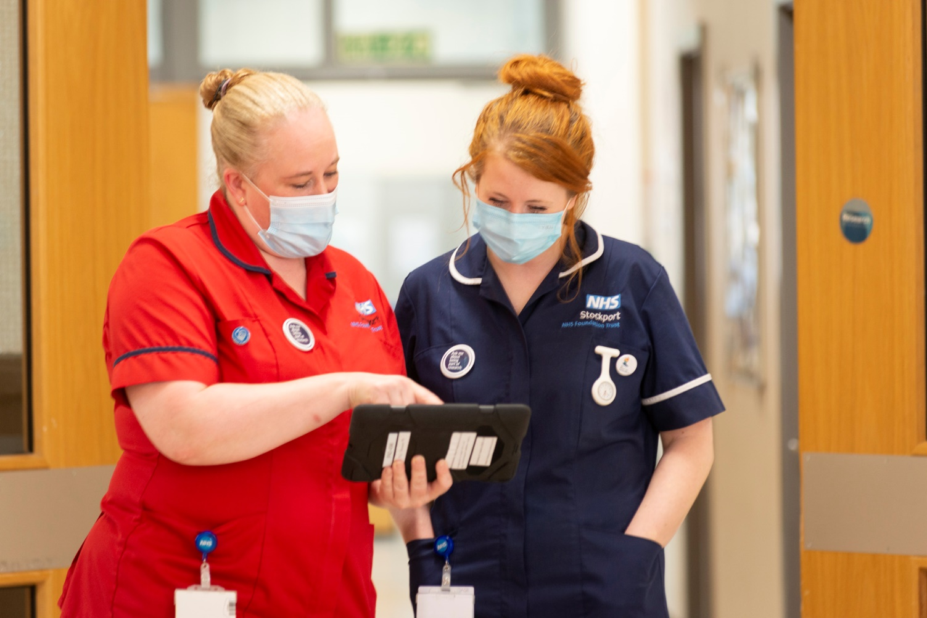

Objective 1.1: Increase and diversify the participation into NIHR portfolio studies
We will ensure a balanced portfolio of studies take place across the two Trusts, supporting established teams but also those yet to participate in NIHR portfolio studies. This will include developing ‘home-grown’, local research ideas to a stage where they are able to be NIHR adopted. Consideration will also be given to the ‘Research Reset Programme’ post pandemic, to ensure balance in our portfolios across COVID-19 and other specialties, supporting general clinical service recovery where we can.

We will do this by considering:

- Type (i.e. observational, complex interventional, new devices, new drugs etc)
- Sponsorship (commercial, NHS and academic, Tameside or Stockport led)
- Inclusive involvement (appropriate recruitment across our representative populations)
- Clinical specialty and setting (i.e. community vs acute, co-morbidity consideration)

We will actively work with our NIHR and commercial partners to seek out and develop improved data systems and digital screening tools, to ensure all patients are offered research opportunities, with a focus on reducing health and care inequalities.

We will also offer the Participant Research Experience Survey (PRES) to all research participants and ensure relevant teams regularly review and act upon the findings to support continued participation.

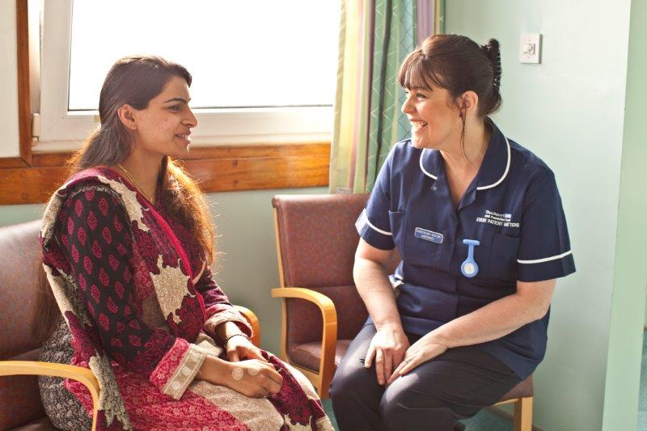

Objective 1.2: Promote inclusivity and develop patient and public involvement for clinical studies
We will support our researchers and patients to meet this objective by raising awareness at a Trust and South East Sector level by:

- Providing advice to researchers on avenues of patient and public involvement at all stages of study development delivery.
- Actively engaging with Trust events, equality, diversity and inclusion teams and NIHR led initiatives (e.g. GMCRN Research Champion initiatives, International Clinical Trials Day).
- Increased use of social media and liaison with Trust communications team to ensure our patients and public are informed about research opportunities local to them, success stories are shared and the importance of research participation showcased.
- Refreshing general Trust information and website content to ensure patients are fully aware of all research opportunities and how to access (including NIHR initiatives: Be Part of Research, Join Dementia Research, Research for the Future etc).

Objective 1.3: Ensure adequate clinical research facilities are available
We will work within our teams, and with senior management to develop dedicated clinical research facilities within each organisation. This will involve making best use of the equipment and space available to provide fit for purpose facilities for our patients and staff.

For all research where integration with clinical departments is preferable, we will ensure research facilities are embedded in clinical departments across the Trusts.

We will also explore opportunities to develop shared facilities and infrastructure with other external partners, such as other NHS Trusts with NIHR badged Clinical Research Facilities, community settings and Higher Education Institutes.



Objective 1.4: Ensure delivery targets for the NIHR Portfolio studies are achieved
Our core RD&I teams will monitor and provide support to enable teams to:

- Proactively and efficiently, navigate the necessary regulatory reviews for a study
- Support assessment of study feasibility
- Streamline set-up times for new studies
- Support teams with recruiting to contracted timelines and enrolment targets (including training on the benefits of the NIHR’s Open Data Platform for this)

Objective 1.5: Provide skilled support for the development of grant applications
We will facilitate, support and advise at all stages of grant development, which will include:

- Sign posting to NIHR affiliated resources to support the grant process (e.g. NIHR Research Design and Study Support services, patient and public involvement)
- Horizon scanning and promoting funding opportunities to researchers
- Mentorship
- Provision of specialist support (e.g. critical reading, project management, methodological, costings, resource review), including guidance from standard operating procedures. This will be through forging partnerships with academic institutions that can provide these expertise.
- Reviewing outcomes from grant applications and reporting back to study teams

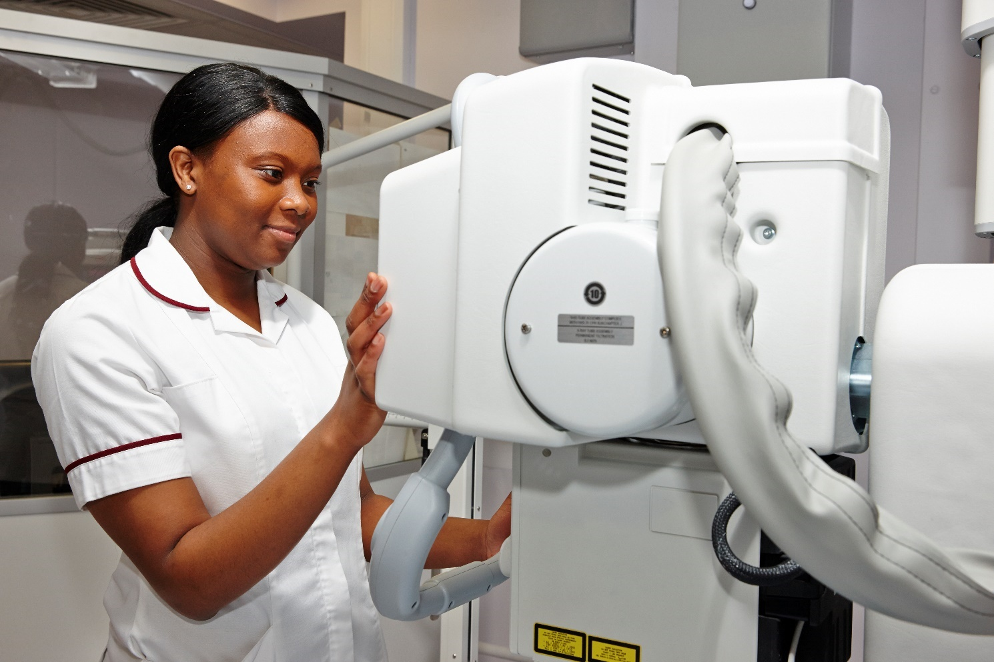

Ambition 2: Embed an inclusive research active culture in clinical service delivery, our community and across the Trusts
We will develop a culture across both organisations, in which RD&I are embedded and aligned with routine clinical services, leading to efficiency and healthcare improvements in health services delivery. To enable this, we will work with the following parameters.

Objective 2.1: Provide protected research time and pump-prime funding for staff who are, or have the potential to be research active
This objective encompasses all healthcare professionals (e.g. clinicians, allied healthcare professionals (AHPs) and nursing staff). This will include:

- Discussion at executive level of departmental job plan reviews and structures, to ensure protected research time is embedded at some level across all relevant Trust areas.
- Supporting with non-recurrent funding bid submissions to the GMCRN (as and when openings arise and proactive discussion) to secure extra staff funding for research delivery.

Objective 2.2: Support career and personal development pathways for staff and researchers at all stages
This objective will encompass succession planning, as well as the identification and support of emerging talent and will:

- Embed inclusivity, ensuring that people with a passion for RD&I have the opportunity to progress regardless of their personal similarities or differences.
- Ensure potentially research active staff are given the opportunity to participate in research by informing on relevant local and national opportunities (e.g. relevant research studies, NIHR campaigns – Associate Principal Investigator programme, workforce training).
- Provide appropriate academic mentorship and training for researchers to apply for appropriate national training programmes (e.g. through the NIHR Training Academy).
- Ensure career pathways are established, clear and actively managed for research staff with current job descriptions and clear induction, appraisal and competency plans.
- Ensure core research teams are fully established with appropriate administrative and clinical support, fit for purpose Standard Operating Procedures, and clear support, development and succession plans in place.
- Actively support, deliver and promote the suite of educational opportunities available through the NIHR Learn website and the NIHR workforce, learning and development team.
- Actively lead the re-formed North West R&D Managers forum to encourage the sharing of best practice and develop the next cohort of R&D Managers regionally.

Objective 2.3: Promote and increase the understanding of all staff of the role of RD&I in high quality clinical care
This objective will scrutinise and re-configure the promotion of research within our Trusts. We will:

- Develop systems to refresh and regularly maintain our social media accounts, intranet content and links with the Trust Communications team to ensure research activity, data, outcomes and its importance is regularly publicised to staff.
- Work with directorates and specialty areas, using NIHR tools and appropriate forums, to raise the awareness of all staff of the value and contribution research makes to practice.
- Hold an annual engagement event at both Trusts for staff to promote our successes.
- Actively engage with NIHR GMCRN, Northern Health Science Alliance and Health Innovation Manchester/ MAHSC initiatives to ensure South East Sector success stories are promoted regionally across staffing networks.

Objective 2.4: Work with staff at all levels to ensure quicker pull-through of the latest techniques and therapies for patient access benefit
We will work closely with senior clinical teams and regional networks (i.e. through Health Innovation Manchester) to ensure that the results of the research we deliver are made available for evidence-based translation into current practice. This will not only support improvements in patient outcomes, but also their experience, and safety as well as cost efficiencies for the Trust.

Objective 2.5: Provide directorates/ divisions with appropriate performance, financial and resource information to support and promote research delivery
We will scope out appropriate accountability reporting structures and provide fit for purpose, regular reports to directorates/ divisional meetings, to confirm research activity and its benefits.



Ambition 3: Become a national leader in integrating RD&I strategically and operationally into developing clinical services

Objective 3.1: Work with partners to identify, develop and maximise our potential of priority clinical areas for translational and applied health services RD&I in our locality
We will focus on our key specialisms across our acute and community settings which have the potential to be national or even world-leading, including shared areas of strength with local academic institutions and care providers. We will build on this infrastructure to enhance research capacity and delivery. We will do this by:

- Mapping our own (and partners) research into key themes, ensuring each has a coherent RD&I strategy to delivery our vision and mission for Stockport and Tameside research.  - We will ensure active support and engagement of these themes from board level awareness to front-line patient care.  - We will actively work with the NIHR GMCRN on their core working groups to deliver on the regional future plan for research. | 

Objective 3.2: Align our RD&I, teaching and clinical service strengths with those across the South East Sector to generate significant health improvements for our patients
- We will actively support and advise on work undertaken by our organisations in pursuing University Hospital status. Such status aligns with the strategic ambitions we have outlined over the next 5 years and will require dedicated project management support to develop our case. This will involve fostering and growing relationships with regional links such as the NIHR BRCs, CRFs and Health Innovation Manchester/ MAHSC to support this ambition.
- We will develop a professorial unit structure designed to bring together academics, universities and Stockport and Tameside healthcare professionals. The aspiration will be to increase and improve research and education in areas where both Trusts have expertise, so that a joint structure is formed between Stockport, Tameside and engaged universities to provide critical mass for clinical researchers (clinicians, AHPs and nurses) to collaborate, develop research interests and skills. This will hopefully convert into increased grant application success and expansion of locally led research ideas being delivered to benefit our population.
- We will establish a strong and robust governance structure led by an executive (that includes active researchers) to guide and inform future strategic developments across both Trusts.
- We will also explore with our regional partners (including other acute trusts, Pennine Care etc) around the potential for “partnership bids” for external awards, so locally-led research ideas can be delivered across the whole South East Sector.

Ambition 4: Increase research funding and utilise to support strategic ambitions
Objective 4.1: Work to maximise external income opportunities, focussing on priority areas
We will explore all avenues of income generation opportunities to maximise funding available to increase our research capacity across the South East sector:

- We will support the work of the NIHR GMCRN as active member organisations, increasing collaborations to progress our portfolios with the life sciences industry to generate more commercial income and potentially increased NIHR infrastructure support as our portfolio grows.
- We work collaboratively with partner organisations to ensure we maximise the chances of NIHR (and other) grant applications.
- We will seek NIHR core funding through the various channels available, to underpin our ambitions.

Objective 4.2: Ensure transparency in financial costings, management and resource allocation
We will provide transparent costings and financial management of research at directorate/ divisional level by:
- Ensuring all commercial research is costed in line with the NIHR national costing template, with representation at national meetings to ensure changes are enacted at site level.
- Ensuring transparent, equitable distribution and performance management of NIHR Research Capability Funding, commercial and other study generated income – Formal updates to the DHSC and relevant Trust committees will be provided as required.

Objective 4.3: Work to increase core Trust research infrastructure funding to realise ambitions
Investment from our organisations to realise these strategic ambitions and to ensure we have a robust quality management and governance structure to underpin our research activities will be necessary. This will need careful consideration of the current RD&I leadership structure and potential to re-configure to ensure it is fit for purpose to deliver on these ambitions.

We will jointly review the current RD&I office structures, delivery teams and accountability and reporting structures across the two organisations, consider strengths, gaps and efficiencies, then develop a new joint-working structure, with a case for change formalised to confirm the investment needed to support our aspirations.

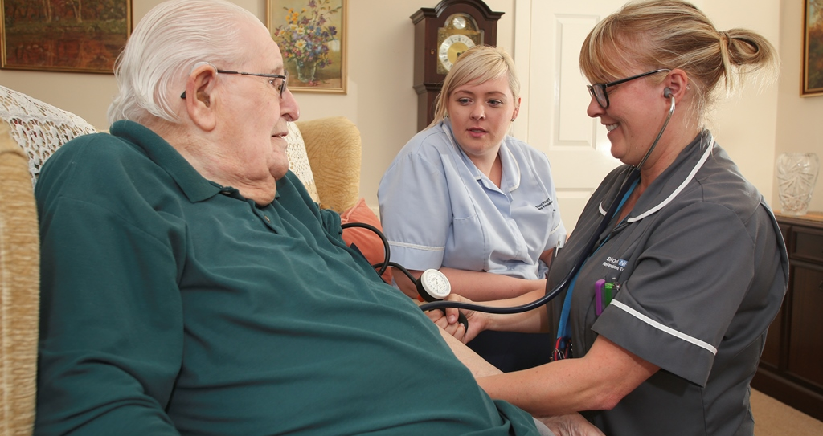

Key indicators of success

The Trusts are committed to ensuring transparency by actively monitor the effectiveness of our plans. The following indicators will be used to assess progress and a detailed priority plan will be prepared to highlight key deliverables for each year

Ambition | Objective | Success Indicator
Ambition 1:  High quality research of direct patient benefit, , tackling health and care inequalities | 1.1: Increase participation and diversity in NIHR studies | Growing number of NIHR studies with Trust participation, with particular emphasis on those presently known to have lower levels of access to RD&I projects due to personal characteristics or socioeconomic status.
 | 1.1: Increase participation and diversity in NIHR studies | An increased number of investigator-initiated research studies with industrial partners and academic institutions, adopted by the NIHR.
 | 1.1: Increase participation and diversity in NIHR studies | Increasing representative sample of participants completing the Participant Research Experience Survey (PRES) with evidence of improvements from feedback.
 | 1.2: Increase patient and public involvement in research studies | An increased proportion of patients recruited to research studies across all groups within our population, with diversity of participants partaking in studies matching local demographics.
 |  | Number of Trust events with RD&I participation.
 |  | Number of patient and public communications promoting research participation.
 | 1.3: Improve clinical research facilities | Dedicated clinical research facilities within each Trust.
 | 1.3: Improve clinical research facilities | Shared facilities and infrastructure with other external partners (e.g. Higher Education Institutes, working with regional Clinical Research Facilities).
 | 1.4: Deliver NIHR targets | Improved metrics for study feasibility, set-up and delivering to time and target, with evidence to showcase our organisation and efficiencies.
 | 1.4: Deliver NIHR targets | An increased portfolio of research studies which has tackled health and care inequalities.
 | 1.5: Support grant application development | Increased number of grant applications supported by RD&I team.
 | 1.5: Support grant application development | An increased number of funding awards/ national leadership positions presented to local researchers.
Ambition 2: Embed an inclusive research active culture within our community | 2.1: Protected research time | Increased number of roles with protected research time from supporting funding.
 | 2.2: Researcher career pathways | An increased proportion of staff being research-active across different groups.
 | 2.2: Researcher career pathways | Increased number of staff given academic mentorship, development and training opportunities.
 | 2.3: Increase understanding of RD&I role in clinical care | Improved engagement of our research workforce (measured by the NHS Staff Satisfaction Survey and local recruitment and retention rates).
 | 2.4: Quicker uptake of new techniques and therapies | Mechanisms developed so research outcomes are shared with senior clinical teams.
 | 2.5: Data and resources to support research delivery | Improved data systems and digital screening tools in place.
Ambition 3:  Integrate RD&I into clinical service development | 3.1: Maximise RD&I potential for translational and applied health services | Increasing research activity among key specialisms.
 | 3.2: Collaboration to improve health outcomes | Embedded joint working model across the two organisations with leadership infrastructure re-organisation to enable this.
 | 3.2: Collaboration to improve health outcomes | Robust university/ academic collaborations in place to support the University Hospital status application.
Ambition 4: Increase research funding | 4.1: Maximise external income opportunities | Increase NIHR core funding.
 | 4.2: Fiscal transparency | Annual reporting on research income, expenditure and performance management.
 | 4.3: Increase research infrastructure funding | Sustainability of our research financial position, allowing year-on-year investment.

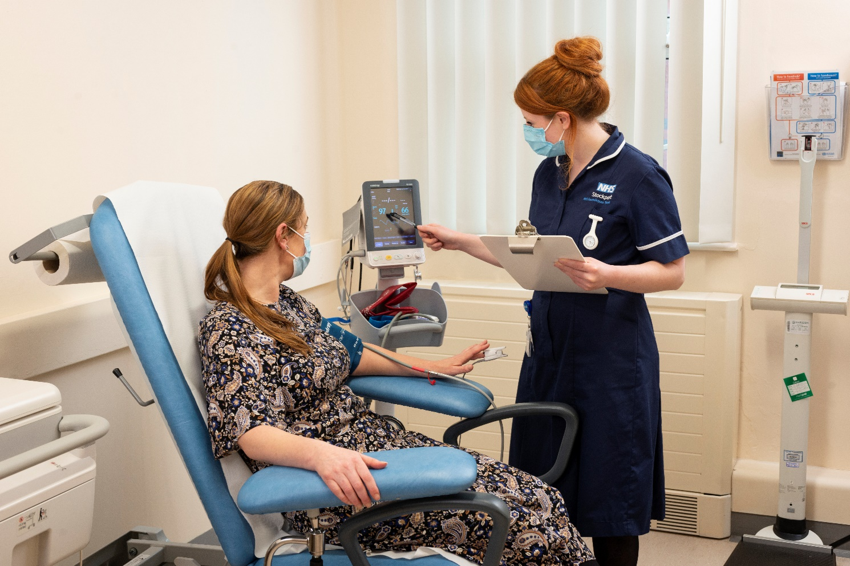

Conclusion

Delivering this strategy will mean that in 2027, the South East Sector of GM will be a thriving centre for research. We will offer opportunities to take part in research to patients across all clinical services in the locality (acute, community and social care). We will have appropriate facilities for clinical research delivery and have significantly increased our rank nationally for research outputs and performance. We will act as a research hub in the South East sector of GM and Cheshire, and boast a national reputation in key areas. Clinical research will be fully integrated into the activity of both organisations and be seen as ‘core business’ by Trust management at all levels. Infrastructure, training and support will be available to increase the number of our staff who both lead and deliver research. We will also be successful in attracting grant funding from the major grant giving bodies. Our joint Trust partnership will be regarded as a system leader in research. We will be well placed to seize further opportunities emerging in the second half of the decade.

Like the NHS as a whole, both Trusts are operating in a challenging financial environment. However, we recognise that delivering this strategy will require investment, which will be reflected in annual business plans over the coming years. An implementation plan will be produced to set out actions to deliver on these strategic ambitions, and the Trust Boards will track progress against this on a regular basis. On-going patient and public involvement will be a key part of implementing our ambitions, as well as empowering our staff to become part of this vision.

Find out more

For more information, contact us at:

Stockport NHS Foundation Trust | Tameside and Glossop Integrated Care  NHS Foundation Trust
Poplar Grove  Hazel Grove  Stockport  SK2 7JE | Fountain Street  Ashton-Under-Lyne  Tameside  OL6 9RW
Phone:  0161 483 1010 | Phone:  0161 922 6000
Email:  Research.Development@stockport.nhs.uk | Email:  Rebecca.Roberts@tgh.nhs.uk  Margaret.Cooper@tgh.nhs.uk
Website:  www.stockport.nhs.uk | Website:  tamesideandglossopicft.nhs.uk


References

https://www.nihr.ac.uk/
https://www.cqc.org.uk/guidance-providers/healthcare/learning-improvement-innovation-healthcare-services
https://www.gov.uk/government/publications/life-sciences-sector-deal/life-sciences-sector-deal-2-2018
https://www.nihr.ac.uk/documents/impact-and-value-report/21427?pr
https://www.nihr.ac.uk/explore-nihr/support/clinical-research-network.htm
https://local.nihr.ac.uk/images/lcrn/greater-manchester/CRN%20Greater%20Manchester%20Future%20Planning%20Brochure.pdf
https://www.gov.uk/government/publications/the-future-of-uk-clinical-research-delivery/saving-and-improving-lives-the-future-of-uk-clinical-research-delivery
https://www.nihr.ac.uk/documents/best-research-for-best-health-the-next-chapter/27778
https://www.nihr.ac.uk/researchers/managing-research-recovery.htm#:~:text=In%20response%20to%20the%20ongoing,capability%20we%20currently%20have%20in
https://assets.publishing.service.gov.uk/government/uploads/system/uploads/attachment_data/file/1013597/life-sciences-vision-2021.pdf
https://www.ahsnnetwork.com/about-academic-health-science-networks
https://healthinnovationmanchester.com/
https://www.gov.uk/government/publications/the-nhs-constitution-for-england/the-nhs-constitution-for-england
https://www.hra.nhs.uk/planning-and-improving-research/policies-standards-legislation/uk-policy-framework-health-social-care-research/uk-policy-framework-health-and-social-care-research/
https://gut.bmj.com/content/gutjnl/early/2016/10/14/gutjnl-2015-311308.full.pdf
Bennett W, Bird J, Burrows S et al. (2012); Ozdemir BA, Kathikesalingam A, Singha S et al. (2015); Boaz A, Hanny S, Jones T, Soper B (2015).
Jonker L, Fisher SJ. The correlation between National Health Service trusts' clinical trial activity and both mortality rates and care quality commission ratings: a retrospective cross-sectional study. Public Health. 2018 Apr;157:1-6. doi: 10.1016/j.puhe.2017.12.022. Epub 2018 Feb 10. PMID: 29438805 https://www.ncbi.nlm.nih.gov/pubmed/29438805
Jonker L, Fisher SJ, Dagnan D. Patients admitted to more research-active hospitals have more confidence in staff and are better informed about their condition and medication: Results from a retrospective cross-sectional study. J Eval Clin Pract. 2020 Feb;26(1):203-208. doi: 10.1111/jep.13118. Epub 2019 Feb 19. PMID: 30784152. https://pubmed.ncbi.nlm.nih.gov/30784152/
https://www.longtermplan.nhs.uk/wp-content/uploads/2019/01/nhs-long-term-plan-june-2019.pdf
https://www.nihr.ac.uk/researchers/managing-research-recovery.htm#:~:text=In%20response%20to%20the%20ongoing,capability%20we%20currently%20have%20in
https://odp.nihr.ac.uk/

